LCMs

<http://wn.com/The_Cicadas_1>

A cicada is an insect:

[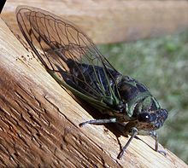](http://en.wikipedia.org/wiki/File:Tibicen_linnei.jpg)

After mating, the female cuts slits into the bark of a twig, and into these she deposits her eggs. She may do so repeatedly, until she has laid several hundred eggs. When the eggs hatch, the newly hatched nymphs drop to the ground, where they burrow. Two types of cicadas go through a life cycle that lasts either 17-years or 13-years.

Both of these compete for the same food supply. They both last emerged in 2011.

1. When will both species next emerge?
2. Why do you think this is such a long time?
3. What is important about the numbers 17 and 13?